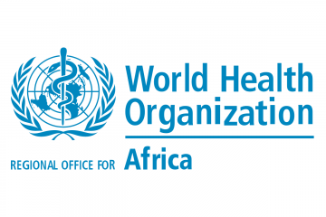

**GHANA**

**COVID-19**

**EPIDEMIOLOGICAL**

**REPORT**

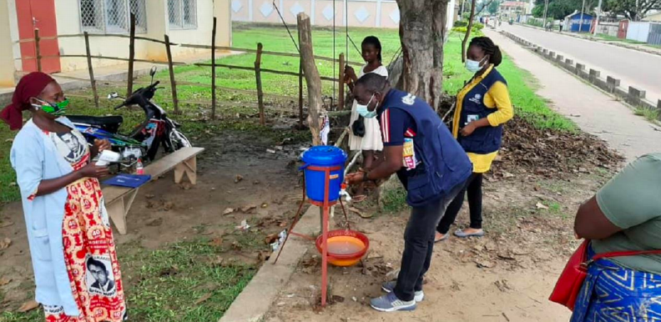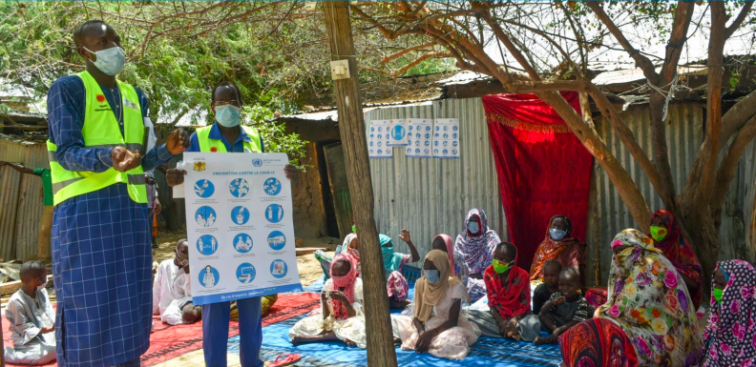

**July 22, 2020**



**1.SITUATION OVERVIEW (Data updated July 16, 2020 )**

Timeline 4

Response 4

Situation update 4

**2. DETAIL (Data updated July 16, 2020)**

**32**

Regional breakdown 9

Age-sex distribution 13

Healthcare workers 14

Testing statistics 14

Factors associated with death 15

**3. PHSM MEASURES**

**6**

Overview 17

Adherence to measures 17

Social impact of measures 18



**4. ISSUES AFFECTING THE RESPONSE**

Economic challenges 20

Infrastructural limitations 20



**5. SITUATION INTERPRETATION**

Situation summary 22

Short-term action areas 22

Long-term action areas 22



**6. APPENDIX**

Symptom onset to report date delay 24

Travel history 24



**1.**

**SITUATION OVERVIEW**

**(Data updated July 22, 2020)**

# 1.1 Timeline

On March 12, 2020, the first two cases of COVID-19 were confirmed. They were imported cases from Turkey and Norway. Policies to trace and quarantine contacts were initiated1. On May 25, 2020, the first case was reported in Ahafa, and on June 1st, 2020, with the first case in Savanah, all districts in Ghana had reported COVID-19 cases1.

# 1.2 Response

On January 21, 2020, the government released the first press communication about COVID-19, outlining the contingency plans, and announcing the formation of a National Technical Coordinating Committee1.

As regards hospital and laboratory capacity, Ghana has laboratories that perform PCR testing at Noguchi Memorial Institute for Medical Research and Kumasi Center for Collaborative Research, and they have developed their own rapid serological test2. In 2020, the country had 545 ICU beds and 200 ventilators3. In addition to receiving PPE supplies from WHO5 there were media reports of donations of equipment from humanitarian missions4 5.

On March 13, 2020, the Public Services Commission initiated workplace contingency measures, including banning all travelling, face-to-face meetings, initiating education programs and guaranteeing the provision of hygiene items to the workers1. On March 18, 2020, a quarantine guideline was released by the Ministry of Health (MOH). All individuals who arrived from abroad were quarantined and tested if symptomatic. This approach was also used in districts with a lower number of infected individuals1.

On April 20, 2020, a partial lock-down was enacted in the Greater Accra and Ashanti regions1. On April 25, the government declared a public health emergency, with mandatory use of masks in public places1. By the middle of May, the number of cases began to decrease.

On May 25, 2020, the first case was reported in Ahafa, and on June 1st, 2020, with the first case in Savanah, all districts in Ghana had reported COVID-19 cases1.

On June 5, 2020, the easing of the lock-down began with re-opening of churches, mosques, other religious institutions, and restaurants. Conferences and weddings were allowed and on June 15, 2020, the schools restarted1. The borders remain closed. During June, the number of cases increased.

# 1.3 Situation update

## National overview (latest data from July 16, 2020)

Case numbers increased steadily until the beginning of May, when they appeared to decrease. This was followed by a second significant increase until the end of June, with a subsequent decrease thereafter. Although testing laboratories and kits are limited, the testing capacity in Ghana is very high. As per a report on July 1st, a gap up to 15 days between sample collection and results occurred and this increased the number of cases rapidly2.







### Deaths from COVID-19

On March 21, 2020, the first death due to SARS-COV-2 in Ghana was reported. The patient had a chronic pulmonary condition1.The number of deaths was stable through April and May and increased in June but the curve appears to be decreasing in July.

## 1.3.2. Cumulative cases and deaths per million (compared to countries in the same region)



Ghana presented the third highest number of cumulative cases per million of COVID-19 in Western Africa. However, when considering the number of deaths, Ghana appears to have a lower number. This could possibly be a result of good healthcare provided to symptomatic patients, and/or a lower burden of pre-existing disease relative to other countries.

The chart below shows the total number of cases, deaths and the case-fatality ratio for countries in Western Africa. Ghana has reported the second highest number of cases, but presents a lower CFR than other countries.



**1.3.2. Cumulative cases and deaths per million (Africa continent)**



Southern Africa appears to be the most affected region on the continent (mostly driven by South Africa). West Africa is the second most affected region, with Ghana being one of the more affected countries.

For the distribution of deaths per capita, Ghana is not as severely affected.



**Table: Case counts, deaths counts and per-capita adjusted values for WHO Africa countries**

|  |  |  |  |  |  |  |
| --- | --- | --- | --- | --- | --- | --- |
| Country | Cases | Deaths | Crude CFR | Population | Cases per million | Deaths per million |
| South Africa | 373628 | 5226 | 1.4 | 56697608 | 6590 | 92.2 |
| Nigeria | 37225 | 801 | 2.2 | 207185471 | 179.7 | 3.9 |
| Ghana | **28430** | **153** | **0.5** | **30536428** | **931** | 5 |
| Algeria | 23691 | 1087 | 4.6 | 43012658 | 550.8 | 25.3 |
| Cameroon | 16522 | 383 | 2.3 | 27884774 | 592.5 | 13.7 |
| Cote d’Ivoire | 14312 | 92 | 0.6 | 25599373 | 559.1 | 3.6 |
| Kenya | 13771 | 238 | 1.7 | 52314849 | 263.2 | 4.5 |
| Ethiopia | 10511 | 173 | 1.6 | 112833693 | 93.2 | 1.5 |
| Senegal | 8948 | 170 | 1.9 | 17452400 | 512.7 | 9.7 |
| DRC | 8443 | 193 | 2.3 | 94058574 | 89.8 | 2.1 |
| Madagascar | 7153 | 62 | 0.9 | 27797000 | 257.3 | 2.2 |
| Guinea | 6590 | 40 | 0.6 | 14352102 | 459.2 | 2.8 |
| Gabon | 6121 | 46 | 0.8 | 1915836 | 3195 | 24 |
| Mauritania | 5923 | 155 | 2.6 | 4546376 | 1303 | 34.1 |
| CAF | 4485 | 55 | 1.2 | 20735261 | 216.3 | 2.7 |
| Zambia | 3326 | 128 | 3.8 | 18918307 | 175.8 | 6.8 |
| Malawi | 3045 | 64 | 2.1 | 19998214 | 152.3 | 3.2 |
| Congo (Rep) | 2851 | 50 | 1.8 | 5950251 | 479.1 | 8.4 |
| Mali | 2475 | 121 | 4.9 | 20525117 | 120.6 | 5.9 |
| Eq. Guinea | 2350 | 41 | 1.7 | 967760 | 2428 | 42.4 |
| South Sudan | 2211 | 45 | 2 | 14839454 | 149 | 3 |
| Cabo Verde | 2071 | 21 | 1 | 552351 | 3749 | 38 |
| Guinea-Bissau | 1954 | 26 | 1.3 | 2118558 | 922.3 | 12.3 |
| Eswatini | 1826 | 23 | 1.3 | 1359068 | 1344 | 16.9 |
| Zimbabwe | 1713 | 26 | 1.5 | 17449538 | 98.2 | 1.5 |
| Sierra Leone | 1711 | 66 | 3.9 | 7119979 | 240.3 | 9.3 |
| Rwanda | 1629 | 5 | 0.3 | 13117385 | 124.2 | 0.4 |
| Benin | 1602 | 31 | 1.9 | 12488112 | 128.3 | 2.5 |
| Mozambique | 1507 | 11 | 0.7 | 31995850 | 47.1 | 0.3 |
| Namibia | 1344 | 4 | 0.3 | 2743745 | 489.8 | 1.5 |
| Liberia | 1107 | 70 | 6.3 | 5095339 | 217.3 | 13.7 |
| Niger | 1105 | 69 | 6.2 | 36399415 | 30.4 | 1.9 |
| Uganda | 1069 | 0 | 0 | 49051105 | 21.8 | 0 |
| Burkina Faso | 1065 | 53 | 5 | 20653498 | 51.6 | 2.6 |
| Chad | 889 | 76 | 8.5 | 22545704 | 39.4 | 3.4 |
| Togo | 783 | 15 | 1.9 | 8262867 | 94.8 | 1.8 |
| Angola | 749 | 29 | 3.9 | 29240847 | 25.6 | 1 |
| Sao Tome e P | 746 | 14 | 1.9 | 210613 | 3542 | 66.5 |
| Botswana | 522 | 1 | 0.2 | 2449622 | 213.1 | 0.4 |
| Tanzania | 509 | 21 | 4.1 | 64577992 | 7.9 | 0.3 |
| Lesotho | 359 | 6 | 1.7 | 2251094 | 159.5 | 2.7 |
| Mauritius | 343 | 10 | 2.9 | 1291483 | 265.6 | 7.7 |
| Comoros | 334 | 7 | 2.1 | 883162 | 378.2 | 7.9 |
| Burundi | 328 | 1 | 0.3 | 13179830 | 24.9 | 0.1 |
| Eritrea | 251 | 0 | 0 | 5930313 | 42.3 | 0 |
| Gambia | 112 | 4 | 3.6 | 2335718 | 48 | 1.7 |
| Seychelles | 108 | 0 | 0 | 98885 | 1092 | 0 |

**2.**

**DETAIL**

**(Data updated May 24, 2020)**

# 1 Regional breakdown

On March 12, 2020, the first two cases of COVID-19 were confirmed. They were imported cases from Turkey and Norway. Policies to trace and quarantine contacts were initiated1. On May 25, 2020, the first case was reported in Ahafa, and on June 1st, 2020, with the first case in Savanah, all districts in Ghana had reported COVID-19 cases1.

## 2.1.1. Daily incidence by region



The most affected regions in Ghana are Greater Accra and Ashanti, with some isolated cases in other regions. Since the epidemic began in Greater Accra, it is possible that this region had been able to control the number of cases by May, therefore resulting in a decrease in the total number of cases. Thereafter, the increase in cases in Ashanti begun to proportionally count for the majority of the country's cases.

Most of the first cases reported in Greater Accra and Ashanti Region were imported through airport borders, while in other regions, the road borders were more significant1. The greatest number of cases occurred in Ghana on week 16 (date?). On April 20, a partial lock-down was decreed in Greater Accra and Ashanti regions1. This appears to have a role in the control of the epidemic, since the number of cases decreased significantly on week 19.

**2.1.2. Cumulative cases and deaths by region**

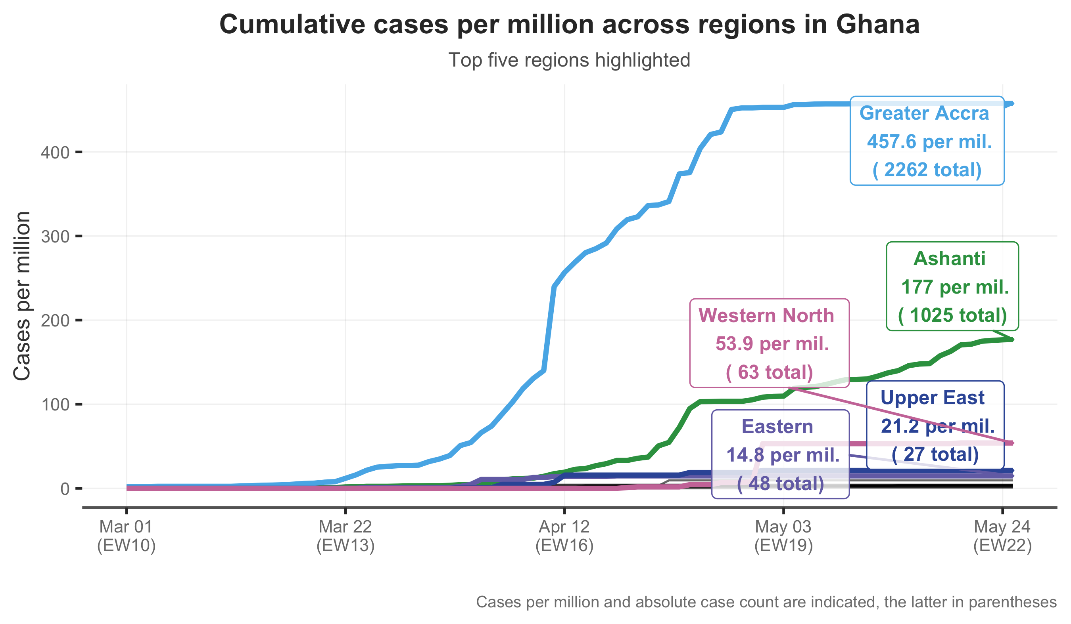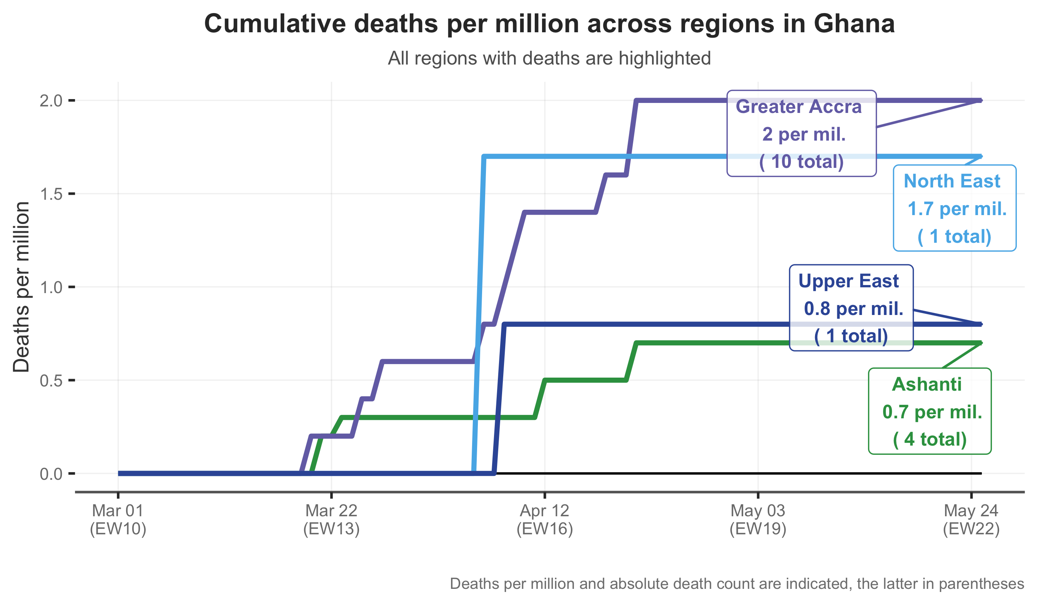

**Cases, deaths, and CFR across regions in Ghana**

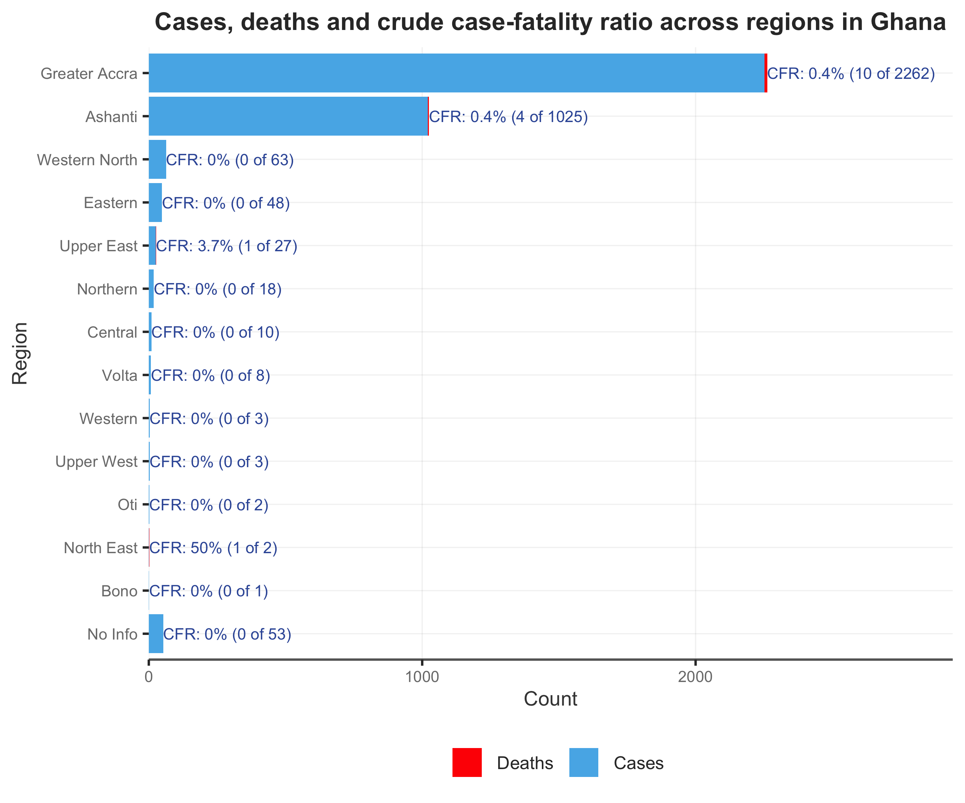

The Case Fatality Ratio (CFR) appears to be the same in the two most affected regions. The CFR seen in Upper East is probably higher because the total number of cases is smaller and any deaths in this situation would increase the CFR in a more significant way.



**Possible sources of vulnerability**

DHS data does not suggest any particular vulnerability for Ashanti and Greater Accra relative to other regions in the country. The relatively high incidence is more likely attributable to the high population density of these two regions, as well as a higher testing rate per capita.

# 2.2 Age-sex distribution

In Ghana, the majority of deaths were reported in people above 50 years of age and the CFR was higher in men. The same pattern was seen in other countries concerning the age of deaths and the gender stratifications.

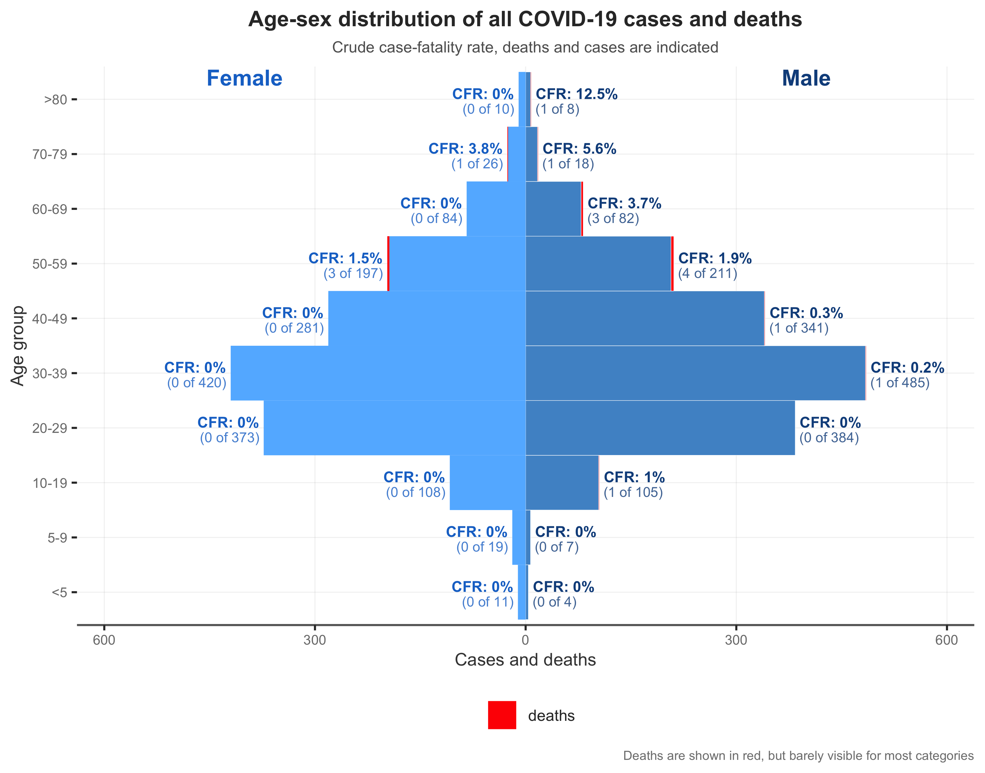

The number of cases in the population over 60 years was smaller than other age groups. This can be explained by the age pyramid in Ghana, with lower number of the population in the oldest strata. Also, there was a big drive to protect and isolate the ageing population, and these measures played a role in this distribution, with higher number of cases in individuals of working age, who were likely s more exposed.

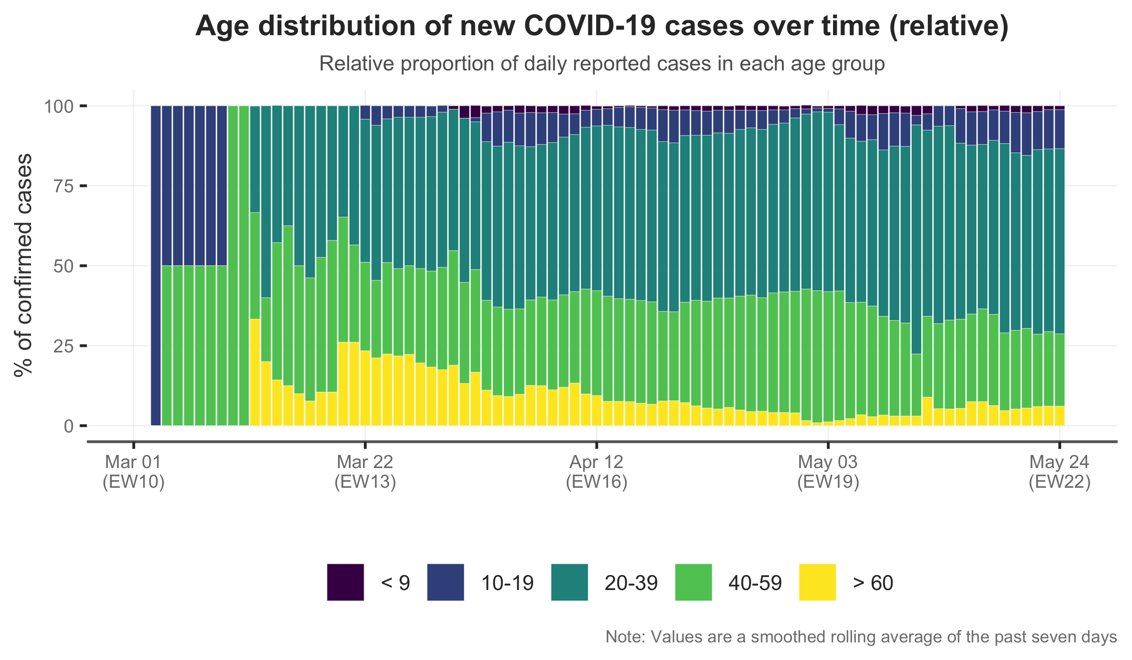

# 2.3 Healthcare workers

The healthcare workers (HCW) were more affected in the beginning of the epidemic. As a measure of epidemic control, the government invested in the training of district health staff. This could have helped the HCW to better protect themselves while caring for infected people. Additionally, Ghana received equipment and PPE from humanitarian missions and from WHO 3 5 6.

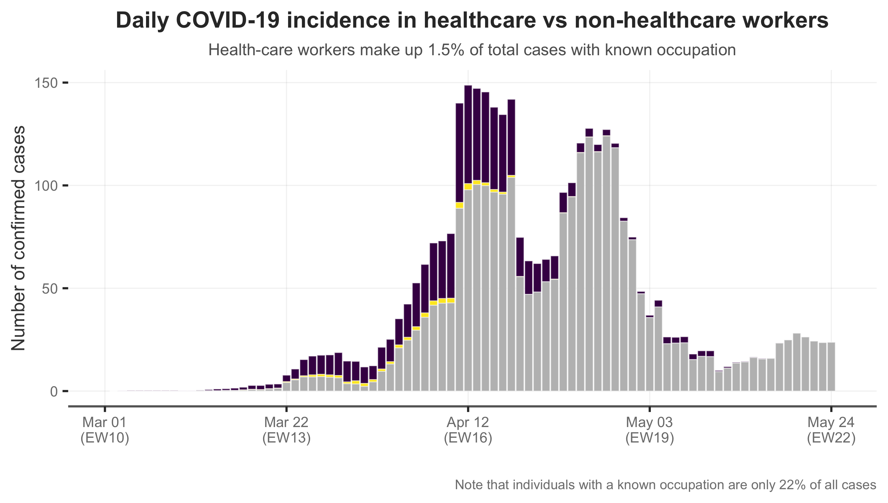

# 2.4 Testing statistics

There are laboratories in the country that perform PCR testing at Noguchi Memorial Institute for Medical Research, in Great Accra, and Kumasi Center for Collaborative Research, in Ashanti1. The presence of a specialized lab in Accra may be the reason for the time interval between lab collection and lab results of only 4 days in that region, but the same can’t be said of Ashanti region that has an elevated time lapse between lab collection and lab results.

The time span between the lab collection and the lab result varies significantly between regions. The region with the quickest results was Western North. Ashanti was the region with the longest time for the results. The number of confirmed cases was 63 versus 1025, respectively. The difference between those region's numbers would explain these differences in time gaps.

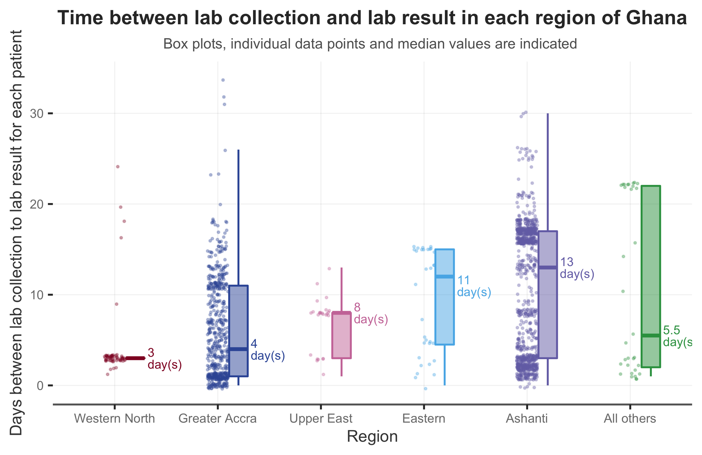

# 2.5 Factors associated with death

In Ghana, the factors independently associated with a higher risk of death related to COVID-19 were male sex, age above 50 years and presence of pre-existing conditions. These factors are the same as in many other countries. Although pre-existing conditions was highly significant, the 95% confidence interval was wide, probably due to small number of cases.

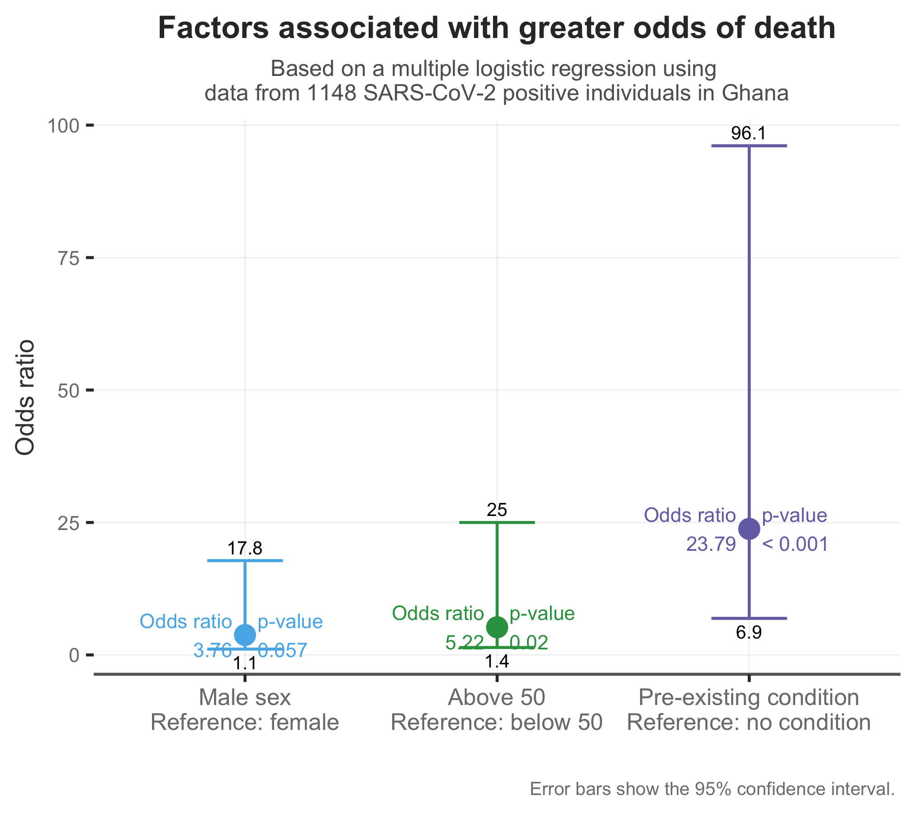



**3.**

**PHSM**

**MEASURES**

# 3.1 Overview

On March 13, 2020, the Public Services Commission initiated workplace contingency measures, including banning all travels and face-to-face meetings, initiating education programs and guaranteeing the provision of hygiene items to workers1. On April 20, a partial lock down was decreed in Greater Accra and Ashanti regions1.

Hand hygiene activities among health care workers and the population were promoted1. Guidelines on the standards for IPC in public places (e.g. provision of hand sanitizers) are available on the ministry of health website1. In June, the policy for discharge from hospital or quarantine changed, using clinical parameters instead of 2 negative PCR tests1. No information on monitoring of PPE (personal protective equipment) stocks was available.

Training of 100 District health staff, engagement of traditional leaders, sensitization of fishermen and dissemination of key messages was undertaken in the Central region. A two-day stakeholder engagement and material development workshop was organized by USAID Breakthrough Action and focused on communication needs assessment for stakeholders to generate knowledge and information for print and audio materials for COVID-19. 50 blind students were sensitized on prevention and control measures. Engagement of the public using mass media was intensified throughout the country6.

On June 5, the country began to re-open starting with the churches, mosques and other religious institutions, restaurants, conferences, and weddings. On June 15, the schools reopened.

### 

# 3.2 Social impacts of measures

It is difficult to analyze whether social distancing measures have had a direct effect on the control of the epidemic, because although the measures were initiated in the beginning of the epidemic, the number of cases continues to increase. However, it is important to note that around 15 days after more strict measures were implemented the number of cases decreased, and conversely, the number of cases increased after these measures were decreased.

The Ministry of Food and Agriculture has commenced the process of developing a post COVID-19 strategy which is to be aligned with the government's COVID-19 response program. This is to improve food supply chain systems and build resilience in the context of the COVID-19 pandemic.



**4.**

**ISSUES AFFECTING THE RESPONSE**

# 4.1 Economic challenges

Many, if not all, markets, have been rocked by the pandemic, including Ghana’s. Five out of the eight listed banks have experienced a fall in their share prices, out of which three experienced a fall of 10% or more for April8.

The Innovation for Poverty Action is undertaking a study funded by the UK Department for International Development, to analyse if mobile money transfers may not help households maintain consumption levels, and complement social distancing policies (Cash and Compliance with Social Distancing: Experimental Evidence from Ghana)9.

# 4.2 Infrastructural limitations

In responding to COVID-19, Ghana faces several challenges, including inadequate IPC resources at point of entry and health facilities (isolation facilities, PPE, and human resources).

Testing labs and kits are also limited, although the testing capacity is very high.

As per a report on 1 July 2020, a gap of up to 15 days between sample collection and results caused a significant spike in the number of cases2.

No information on monitoring of PPE (personal protective equipment) stocks was available.

The suspension of some public health response activities like the immunization campaign against Polio virus can be a problem for the management of other diseases in the future.



**5.**

**SITUATION INTERPRETATION**

# 5.1 Situation summary

From the first two imported cases to now, 27060 cases of COVID-19 were reported and 145 deaths. Although, Ghana was the third most affected country in the area, the same was not observed in the cumulative number of deaths. Considering these data, the CFR in Ghana is very low. It may be explained due to the quality of care provided, as well as the high number of testing, with testing possibly (oligo)asymptomatic patients.

Since Ghana presented with a very high testing capability (as compared with other countries in the area), the last hypothesis should partly explain their relatively high cases per capita.

As in other diseases, the main risk factors independently associated with death were older age, male sex, and pre-existing conditions. Biological mechanisms underlying these risk factors have been proposed (e.g. lower expression of angiotensin-converting enzyme 2, reduced respiratory function) as well as social determinants.

The cases have appeared to spread through the international routes (airport and main national roads) to the most populated areas: Greater Accra and Ashanti.

Case growth slowed 15-30 days after the partial lockdown, but now continues to rise.

The impact of the pandemic in HCW was mitigated with proper training and PPE distribution.

Decrease the timing gap between testing and results.

# 5.2 Short-term action areas

Study and discuss the causes of death, in order to mitigate the number of deaths in Ghana

Ramp up contact tracing in affected regions.

Evaluate the impact of the pandemic on domestic violence.

Describe the pandemic’s socio-economic impact in Ghana, to study possible actions to improve the situation on long term.

# 5.3 Long-term action areas

Improve access to psychological support for the population, considering the sequelae of long-term isolation, loss of family members, and the possible increment on domestic violence.

Improve access to health care, in order to mitigate the clinical sequelae from the SARS-COV-2 infection.

Evaluate possible immunization catch up campaigns, to update the delayed vaccines from the population.

During and after the pandemic, consider African and universal consortia of data, to understand epidemiological and risk factors associated with cases and deaths associated with COVID-19.



**6.**

**APPENDIX**

### Symptom onset to report date delay

The time delay between the beginning of symptoms and the reporting date is relatively small in Ghana. Since, at the beginning of disease onset, symptoms of COVID-19 are mild, it is possible that people wait some days to search for care in the health facilities. But it is important to notice that the time delay is different from region to region, which is an important indicator since policymakers should try to reduce this delay as much as possible.

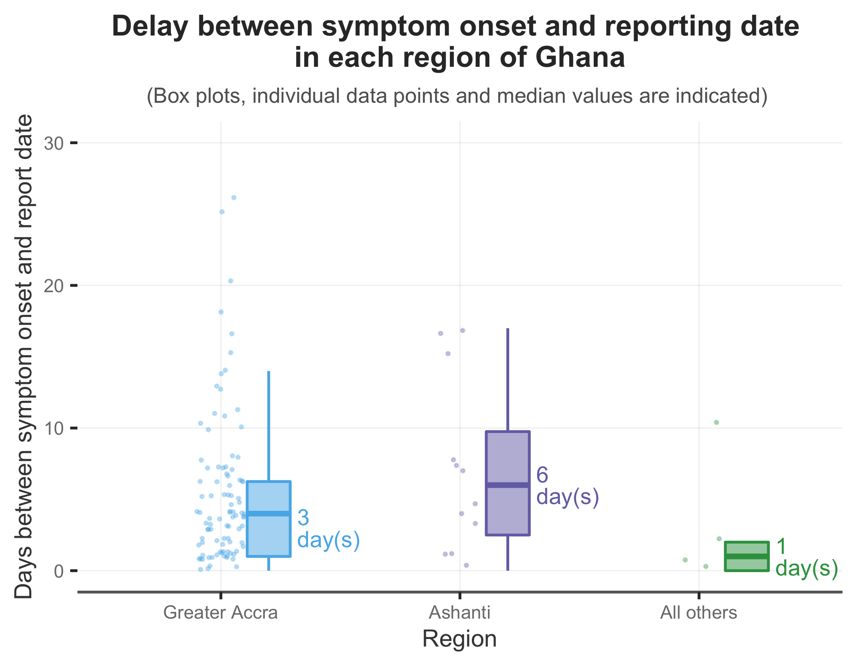

### Travel history

In Ghana, the confirmed cases with a travel history accounts for only 10% of the cases of COVID-19 notified in the country. Even though, the information of the most visited countries is useful for the surveillance teams responsible for the managing of the travellers arriving at Ghana and for the quarantine policy.

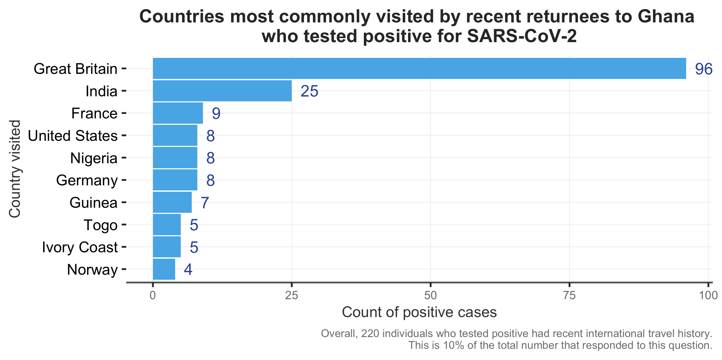

### Regional case summary

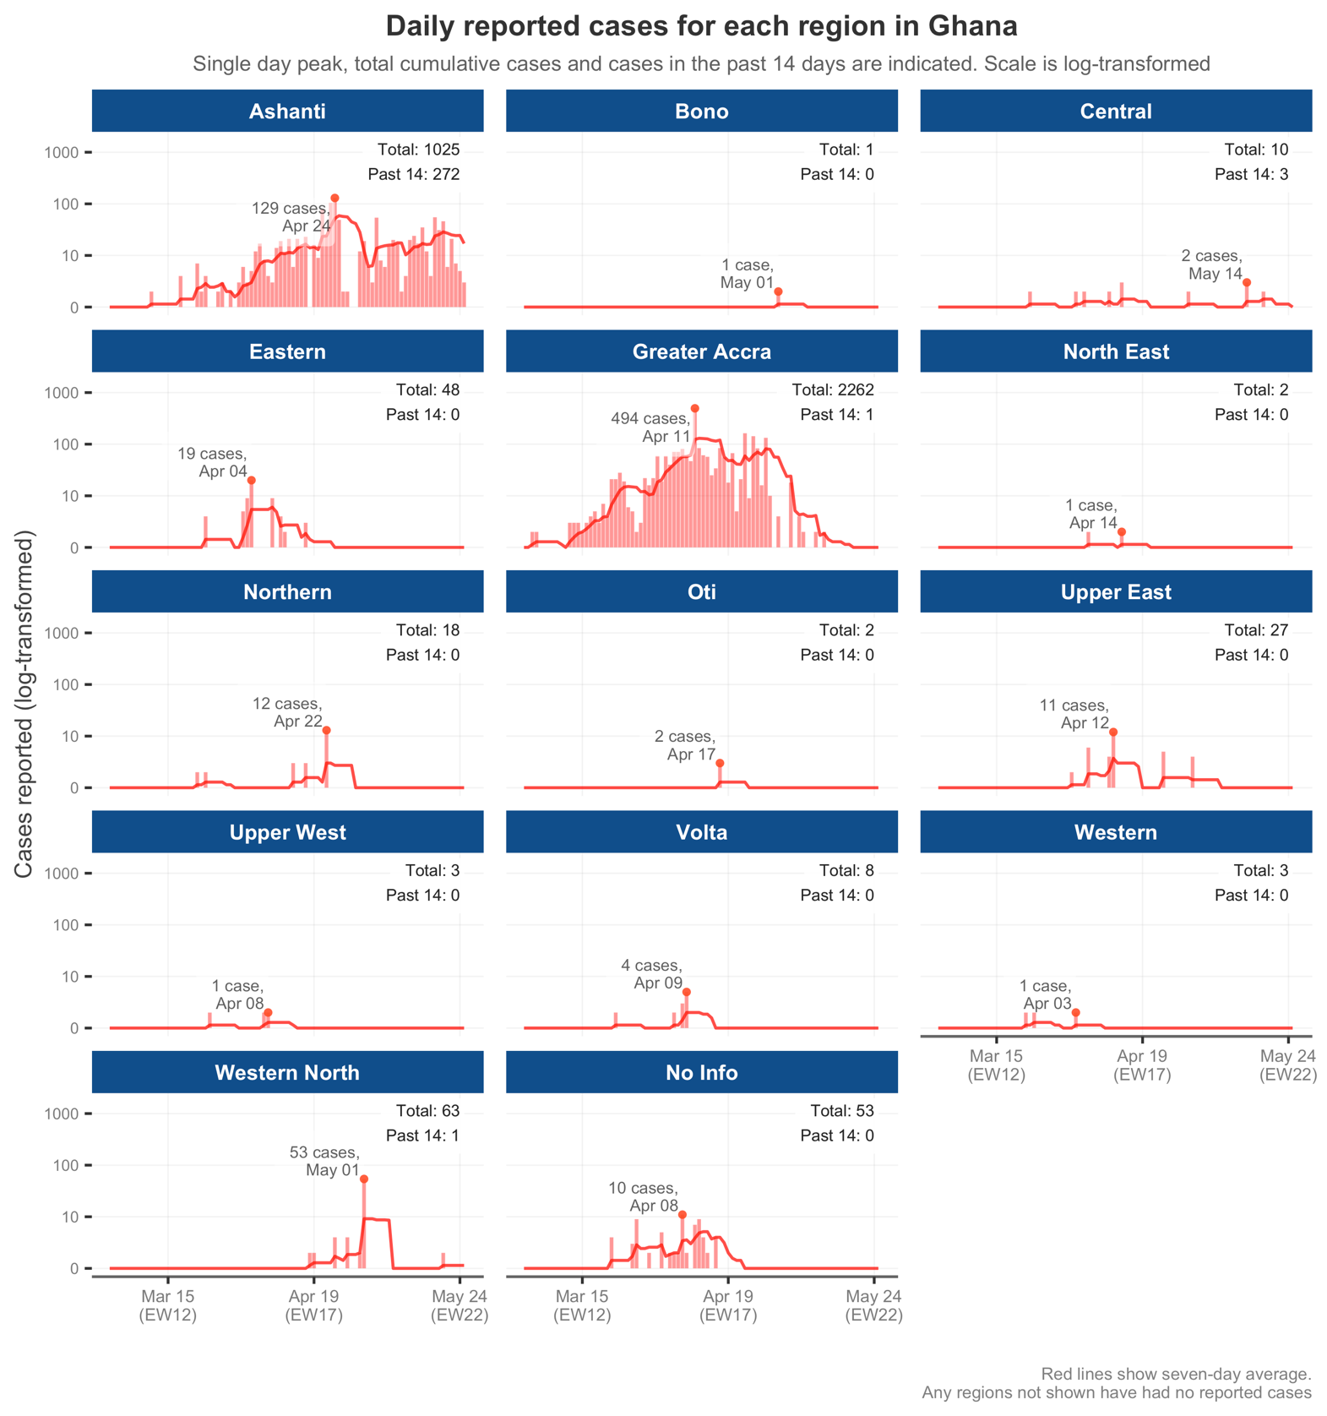

### Regional deaths summary

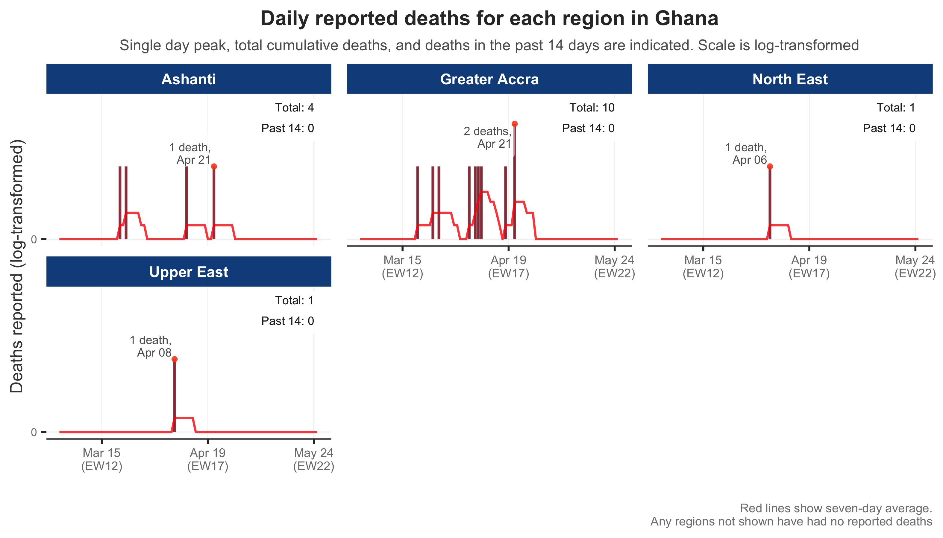

### Epidemic-progression maps

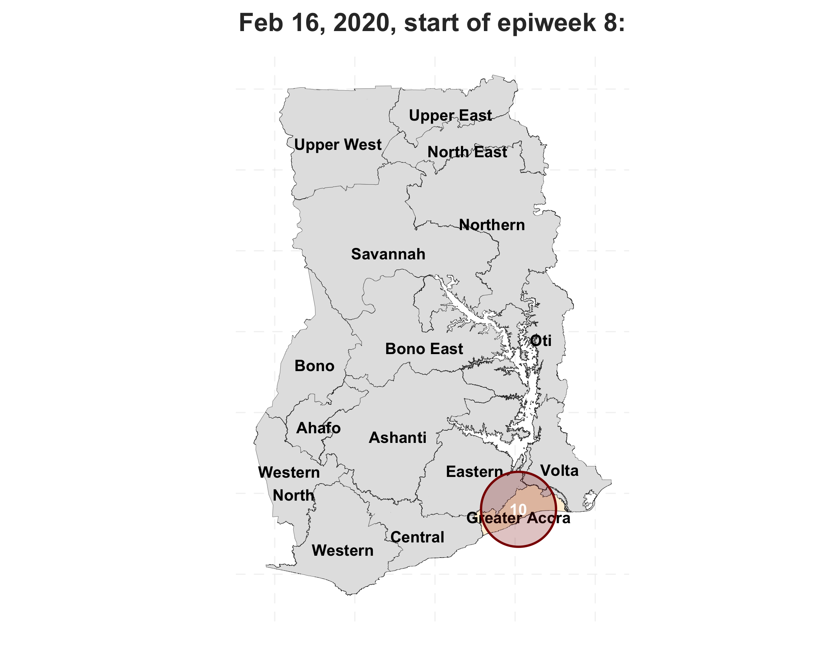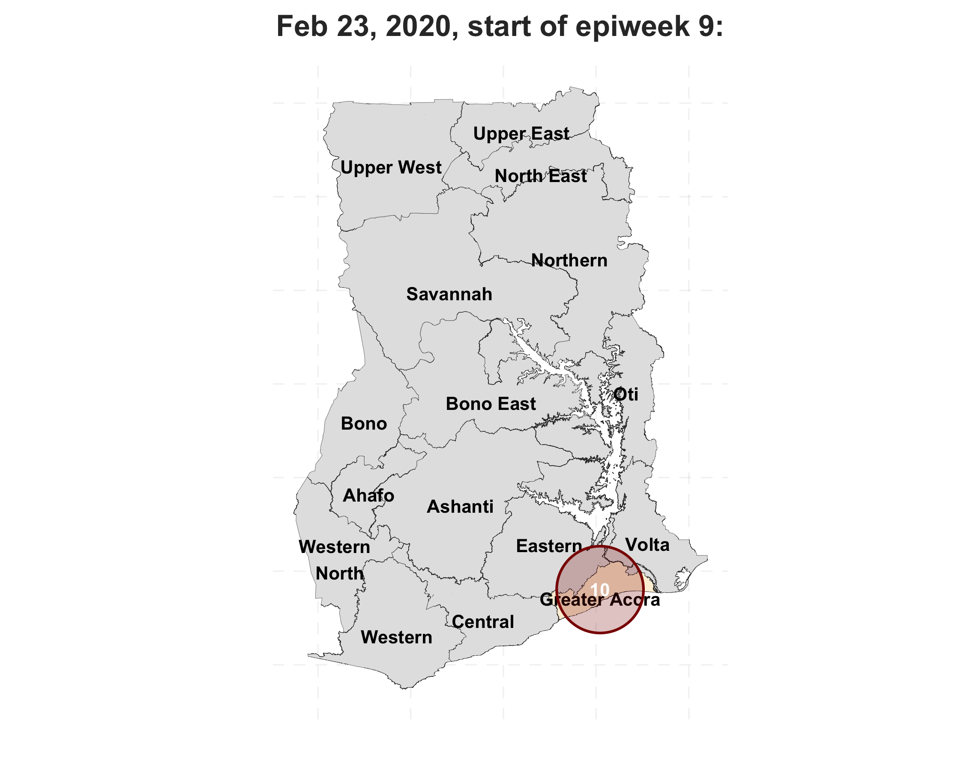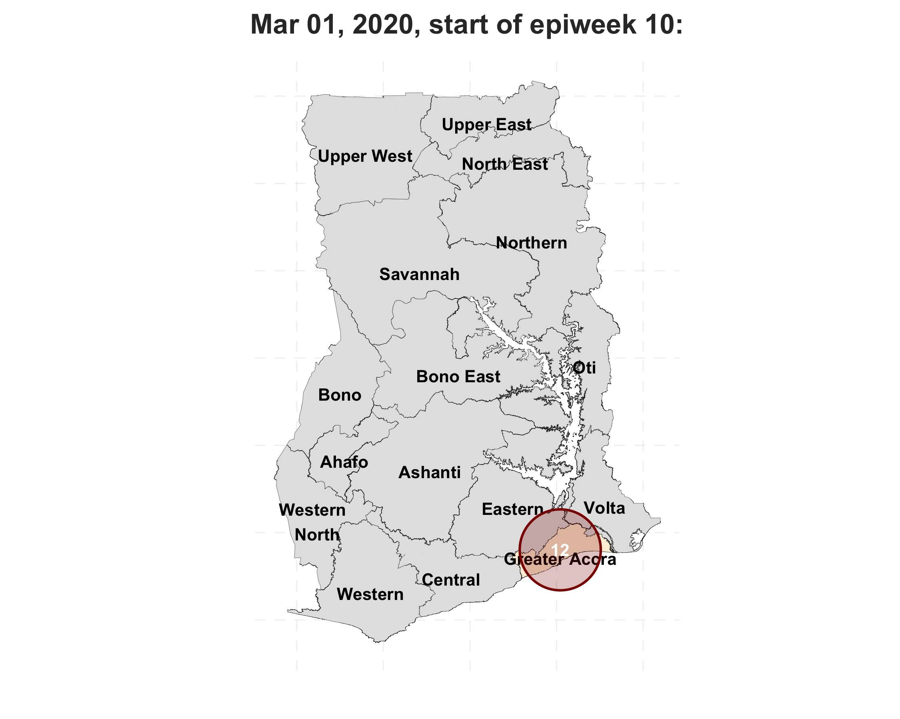

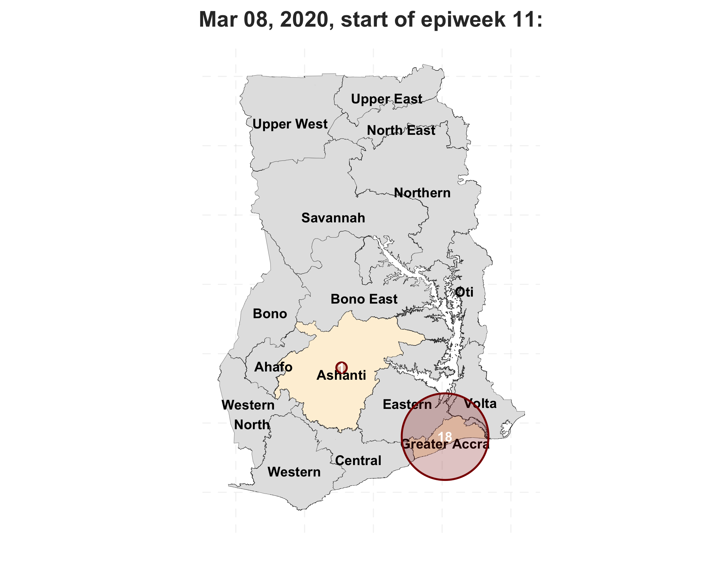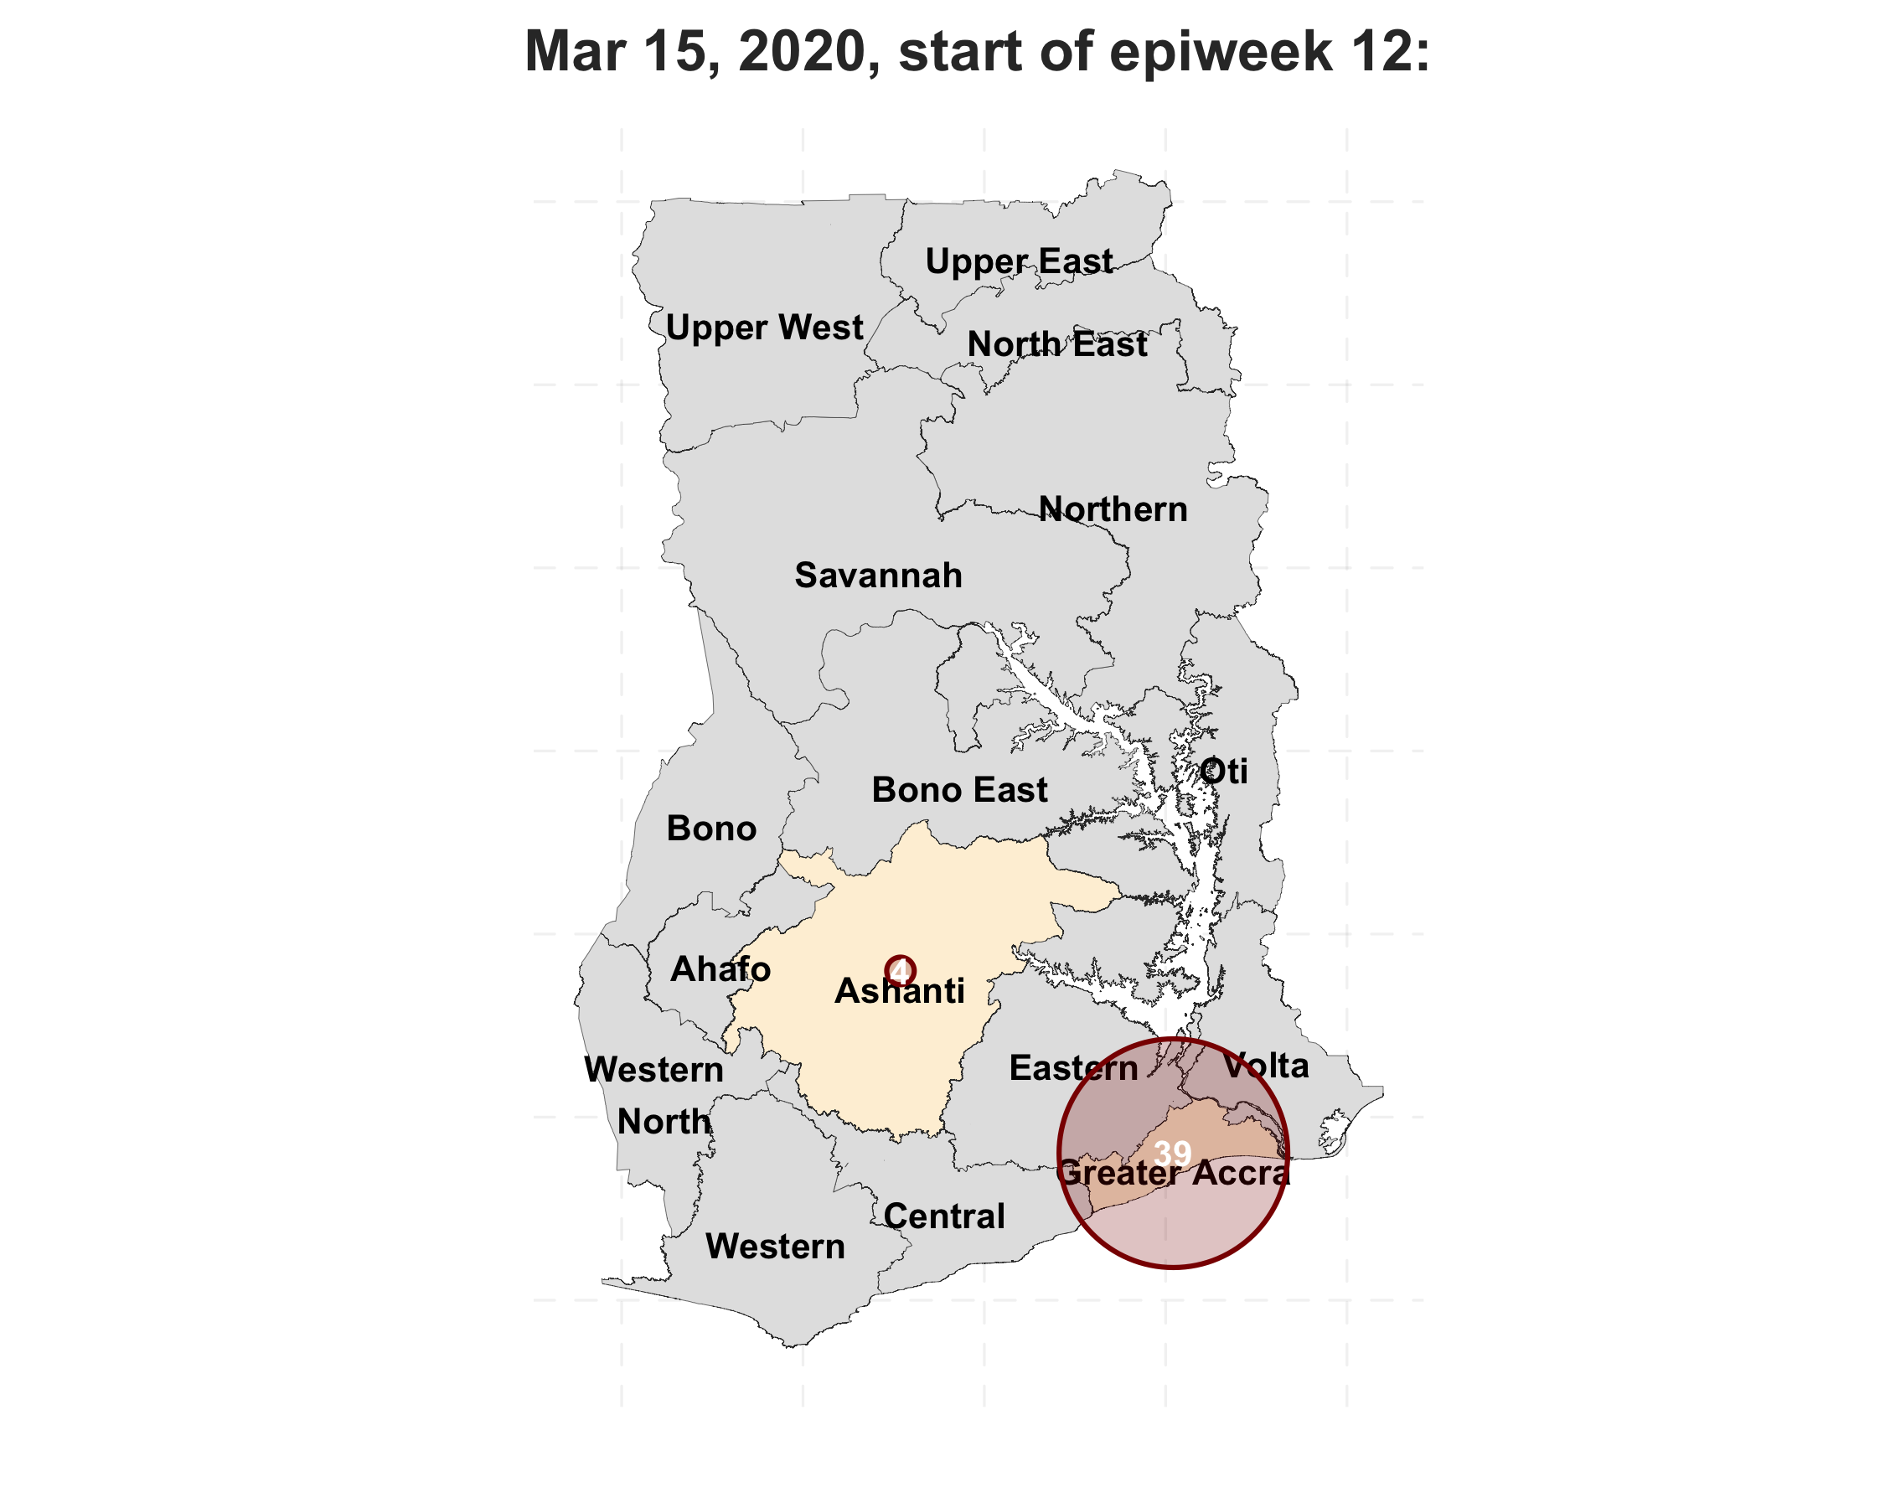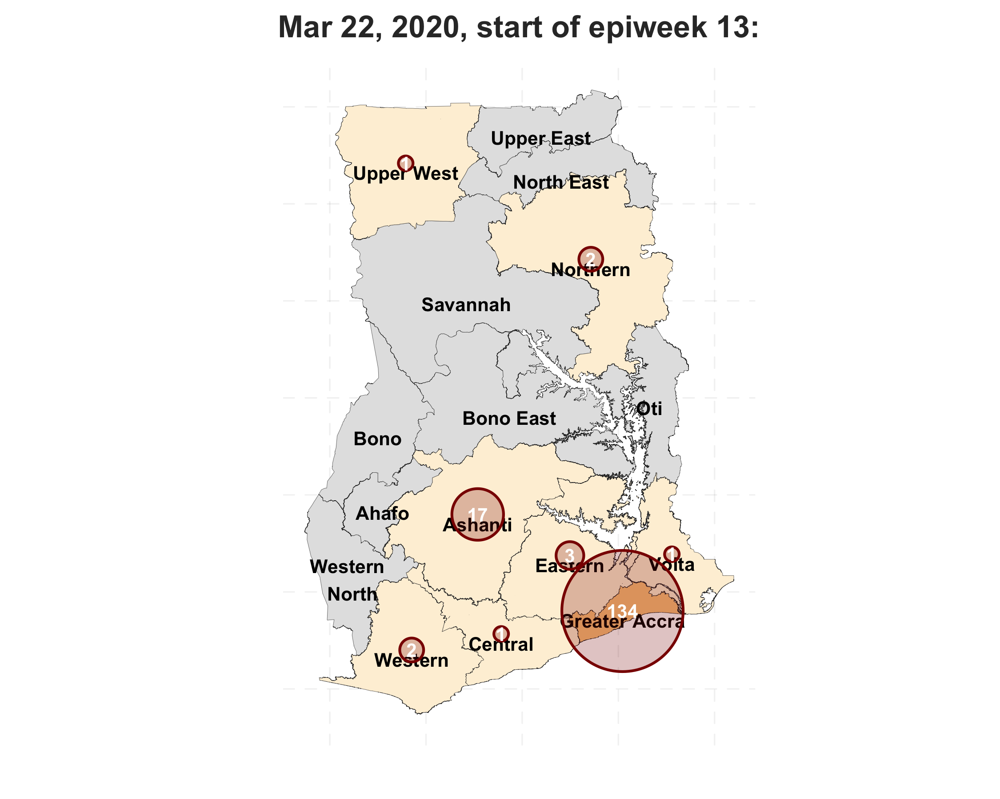

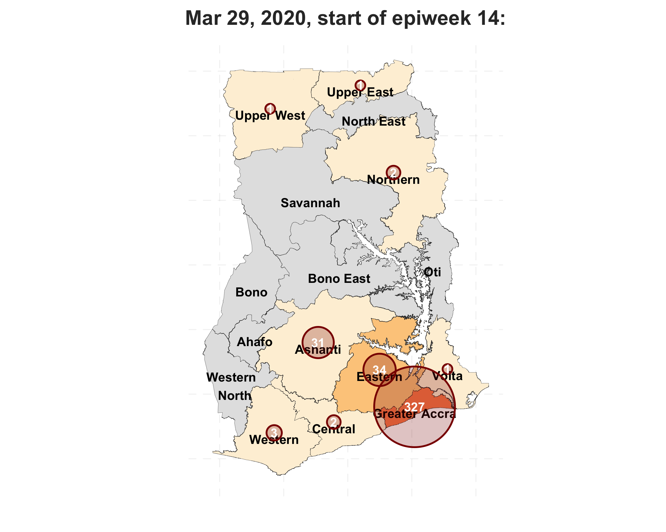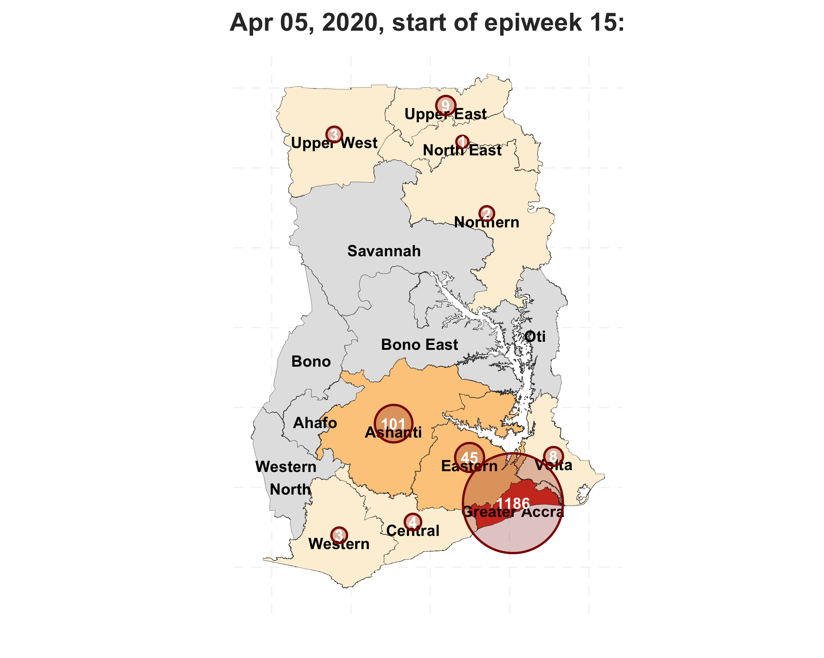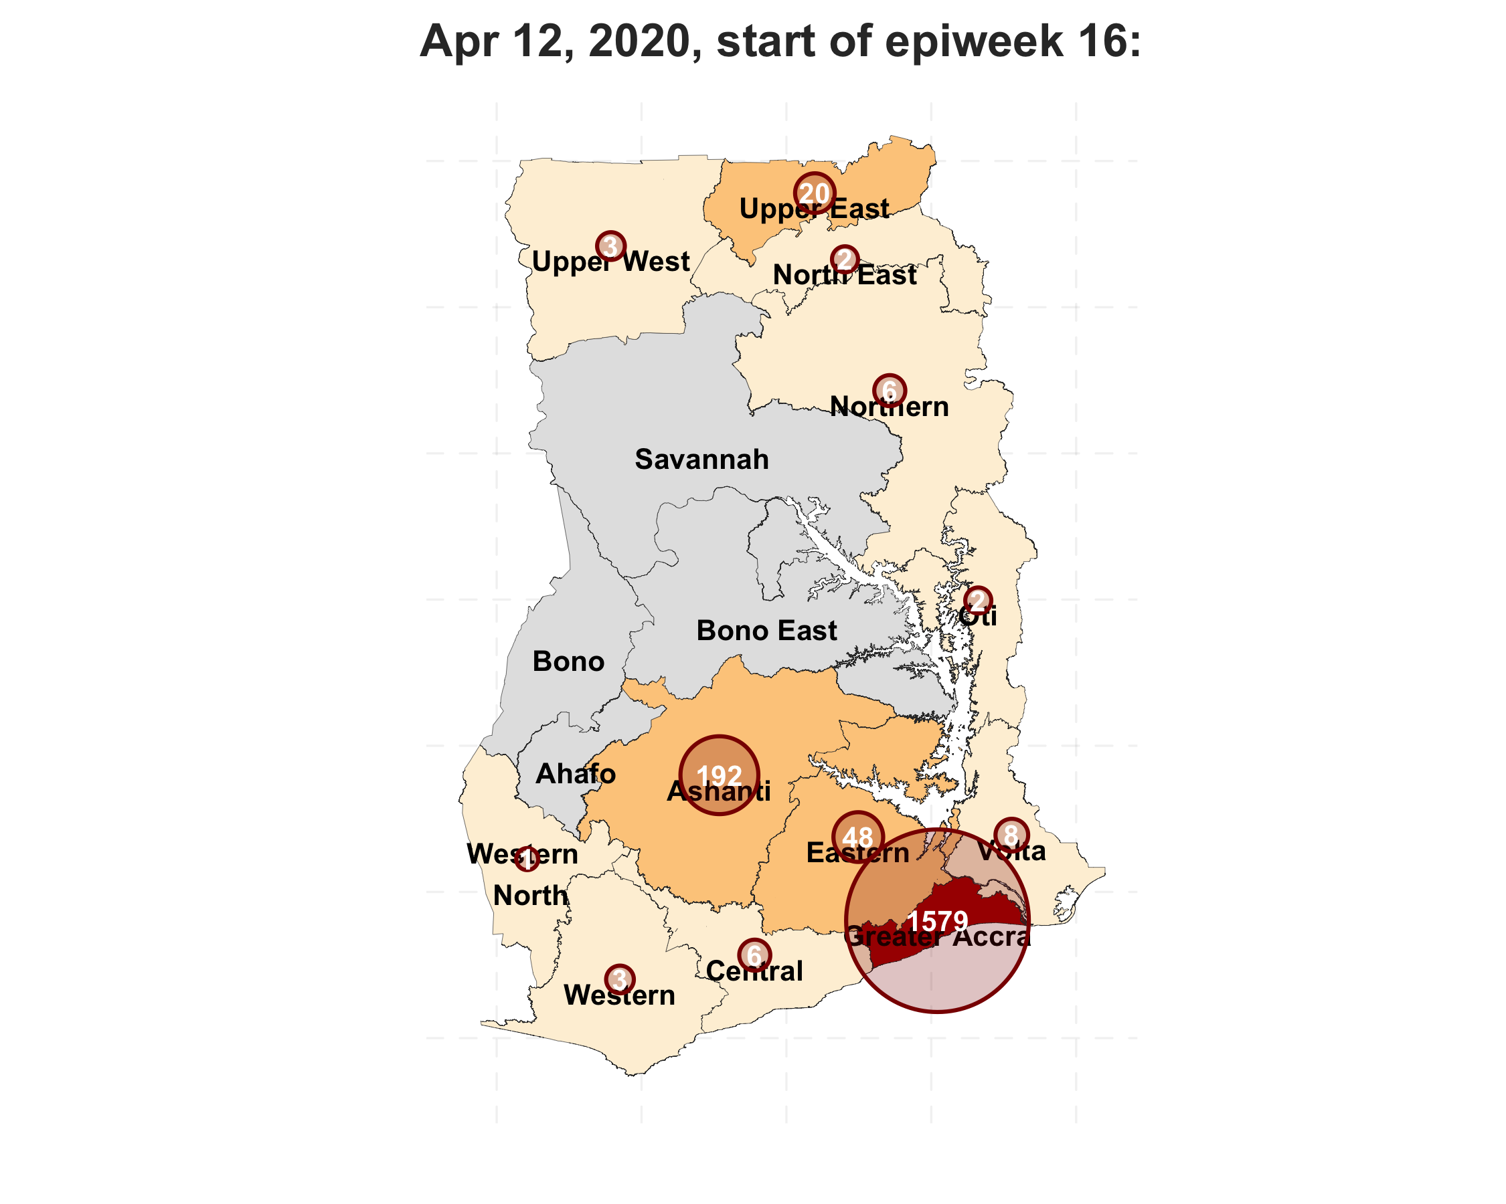

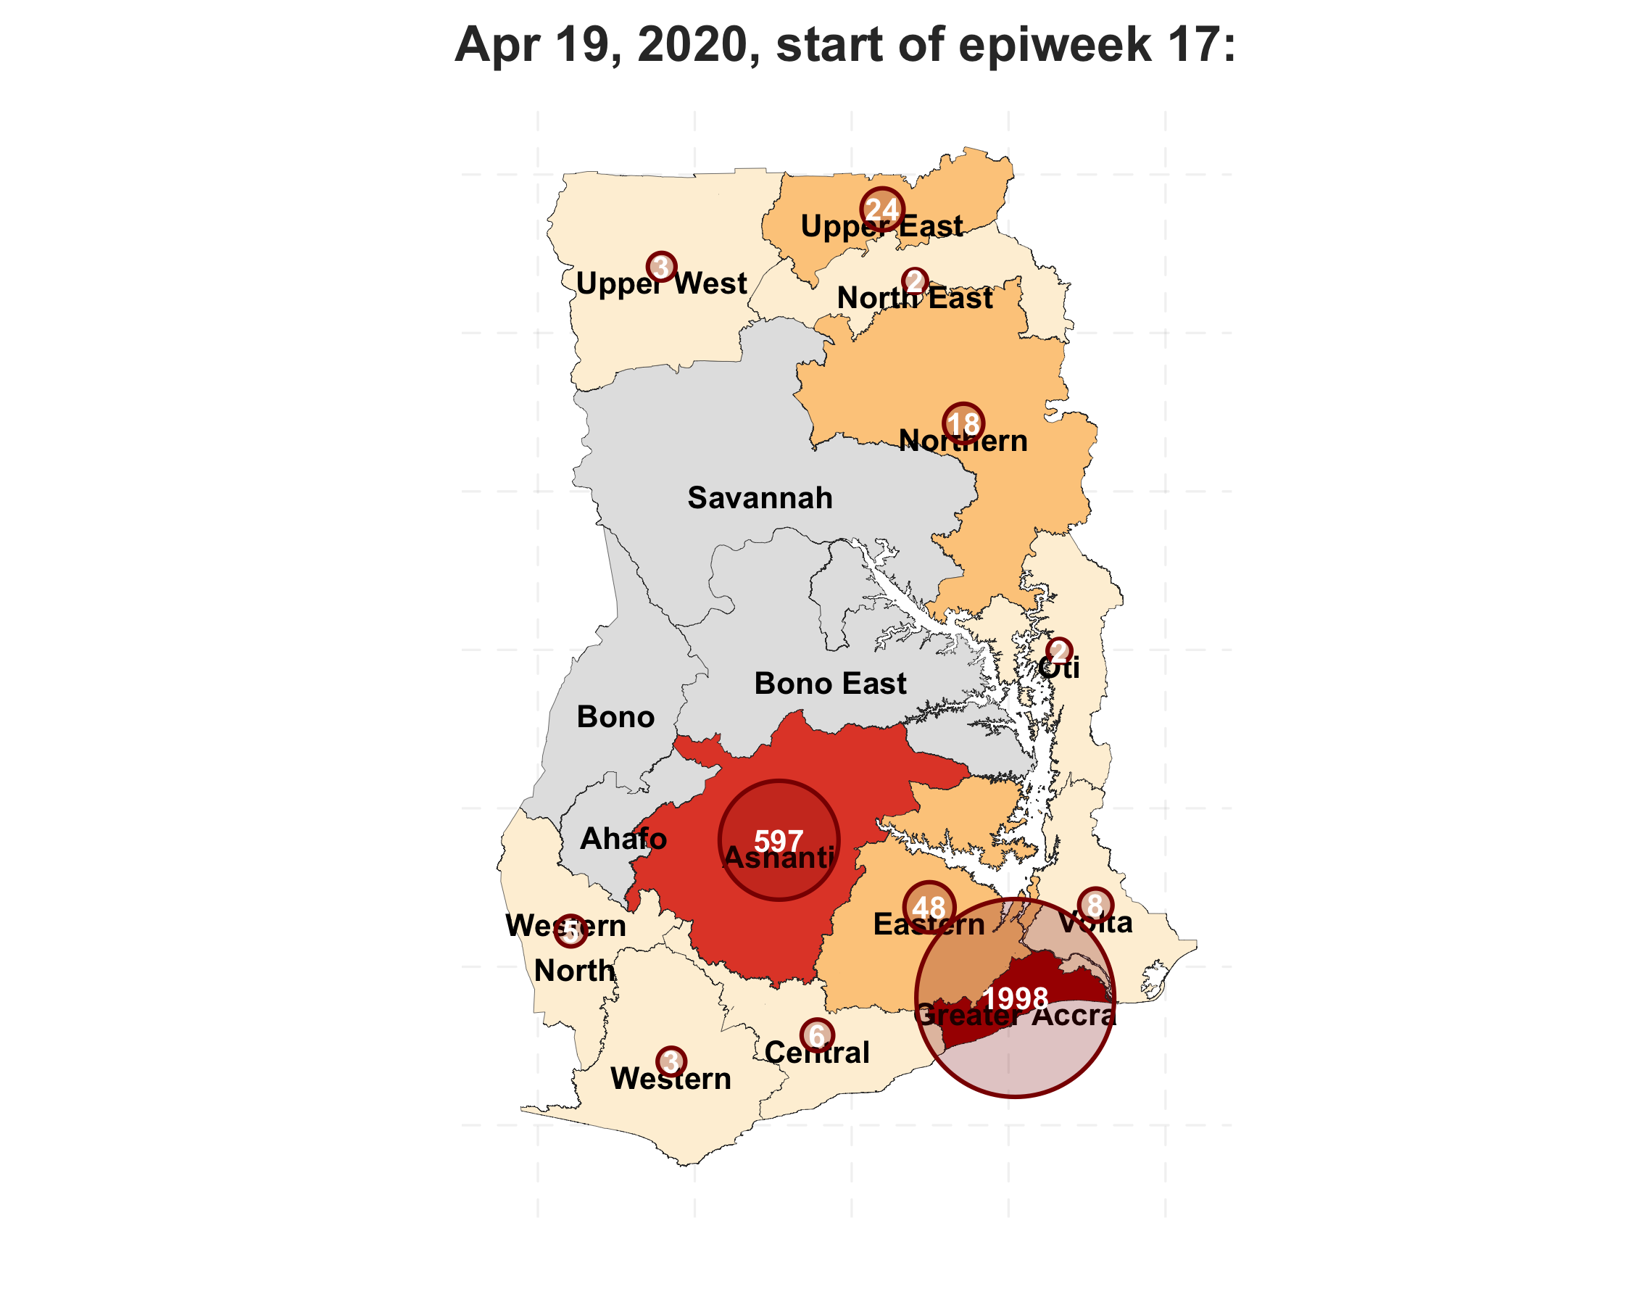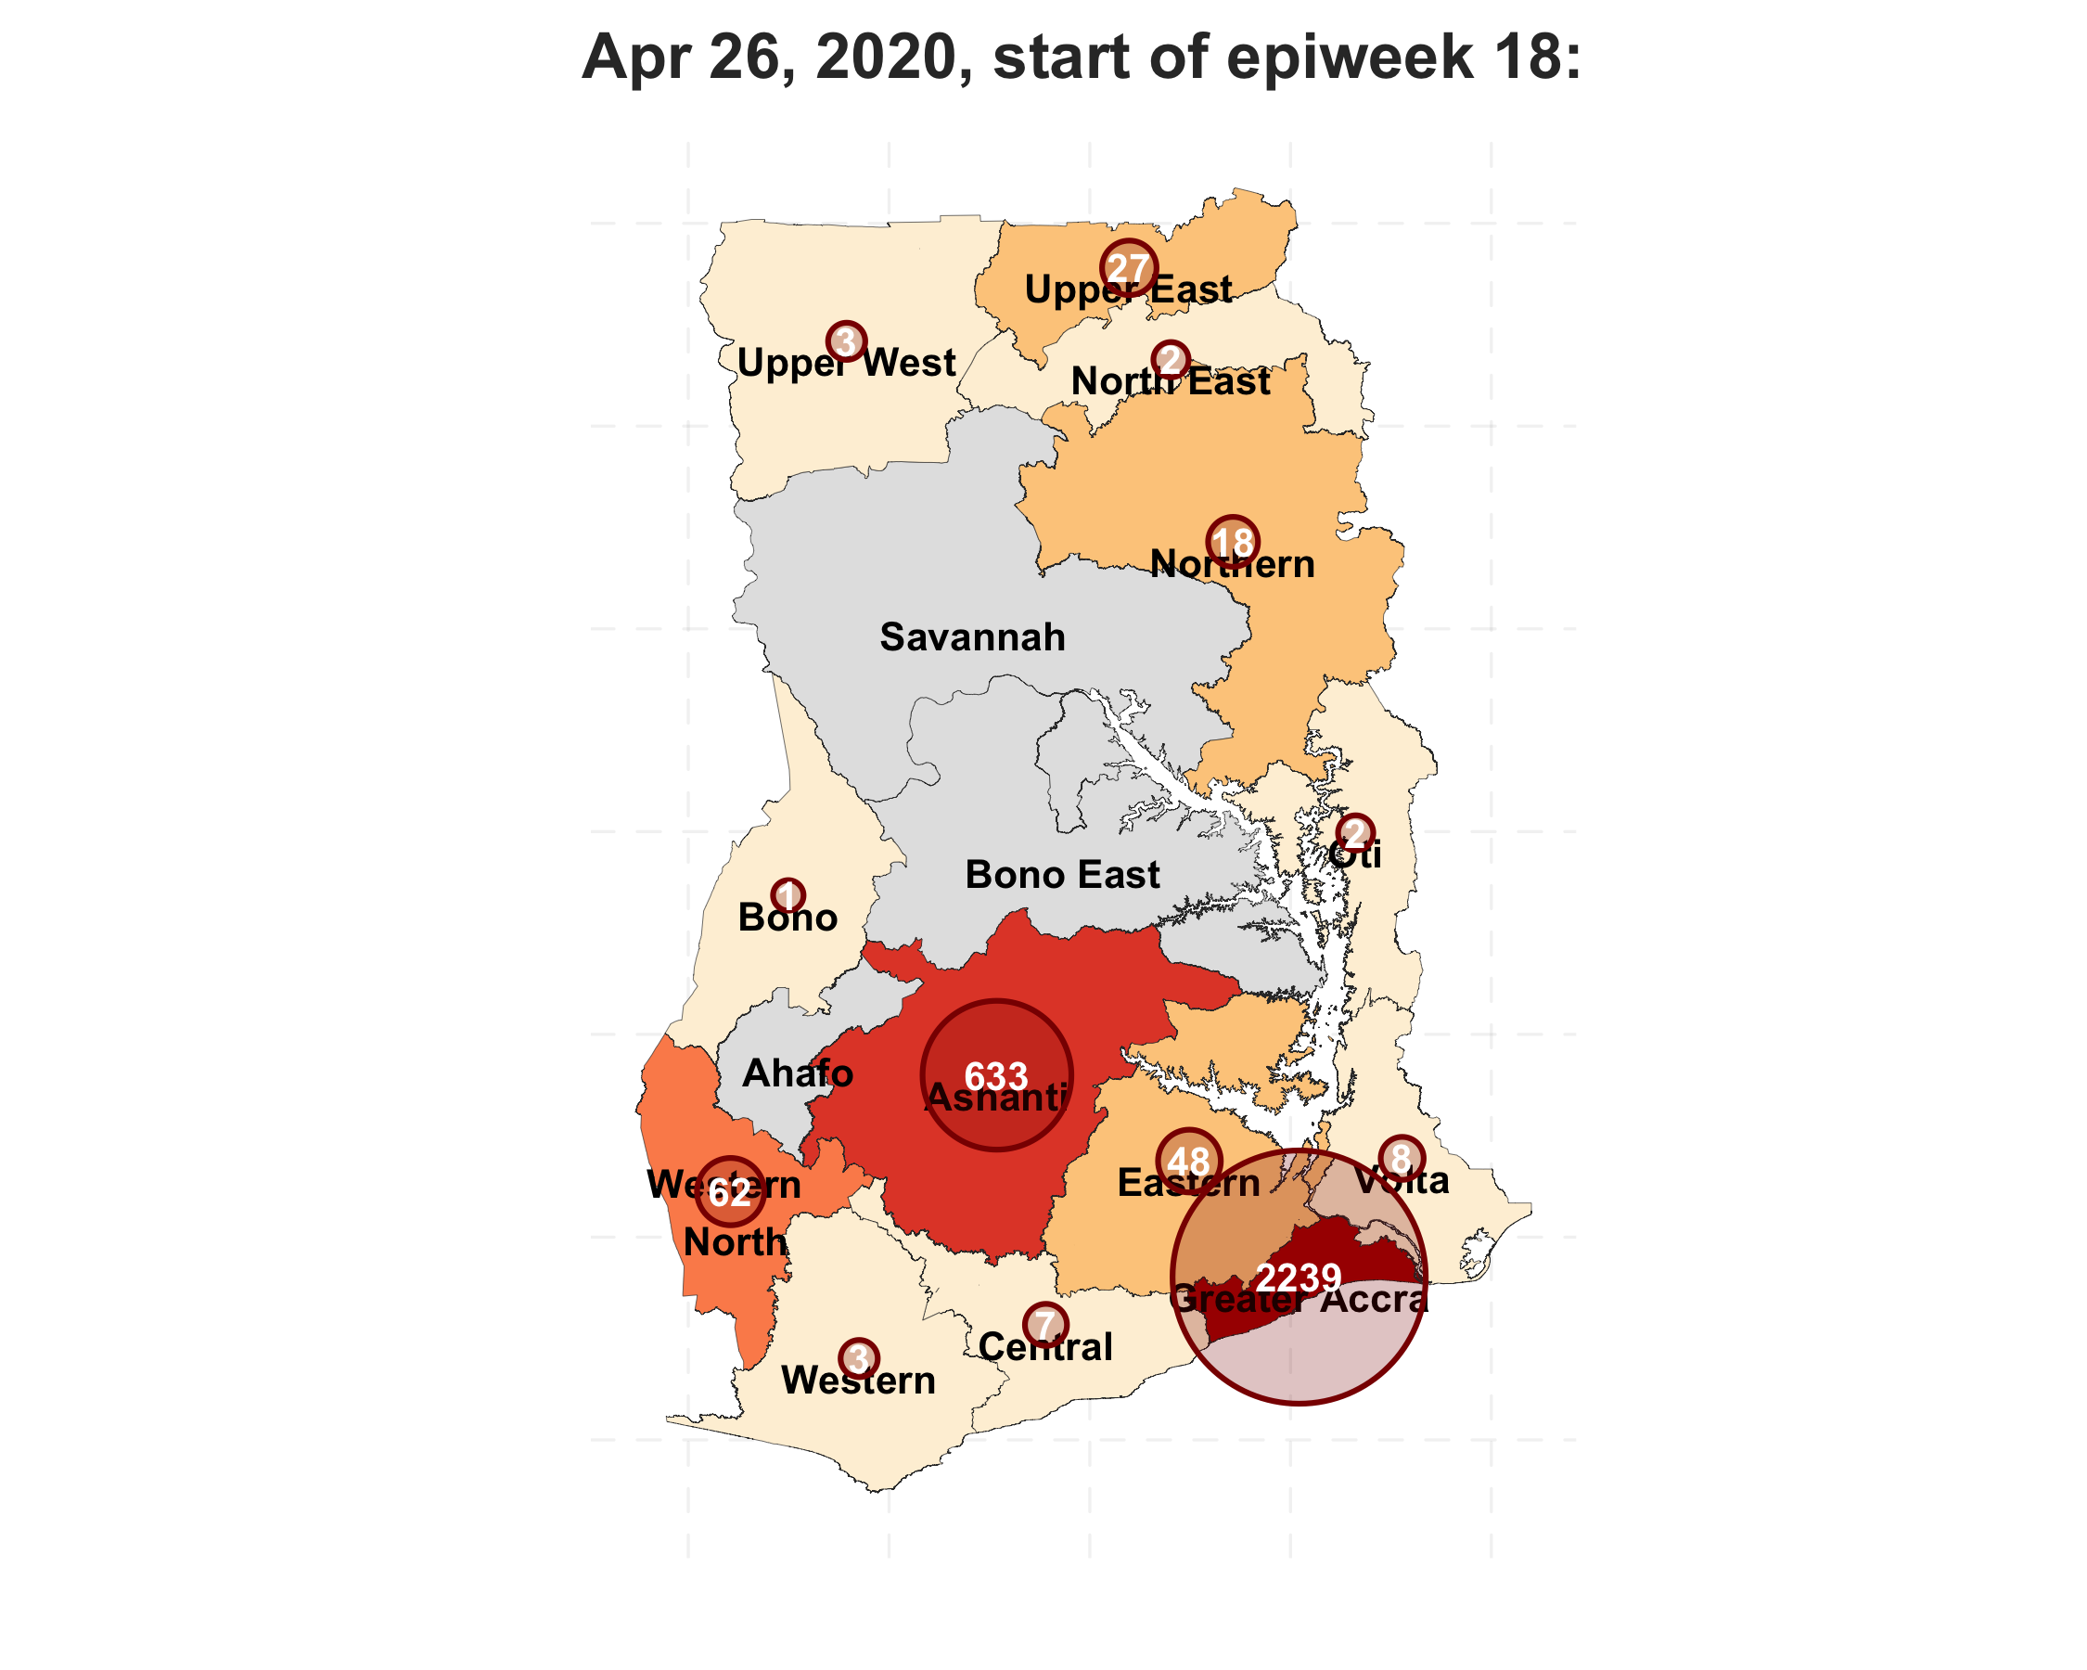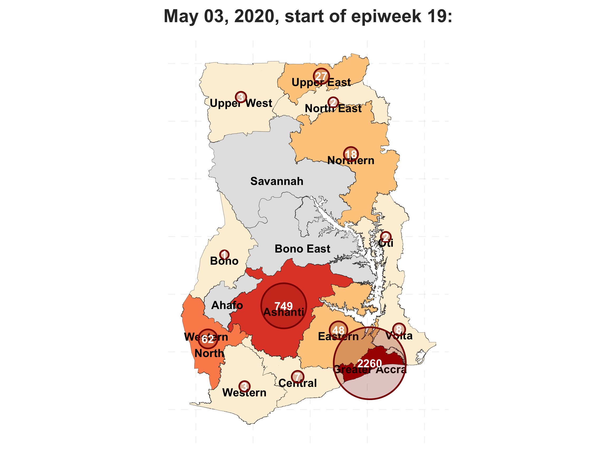

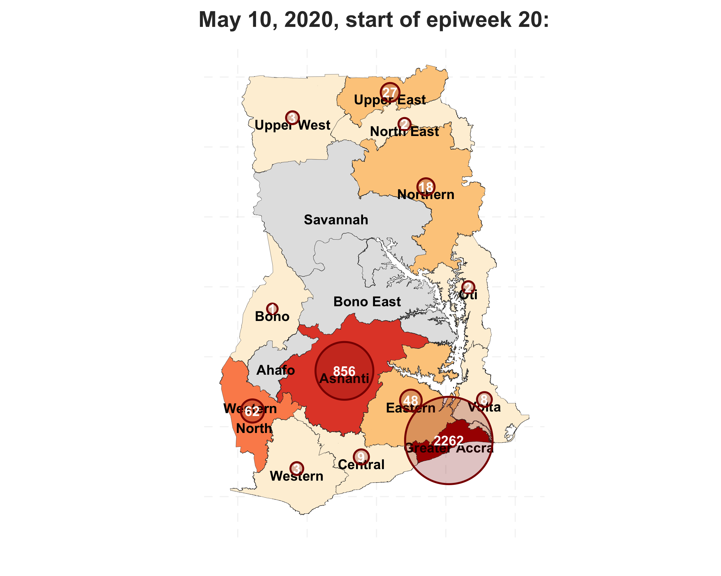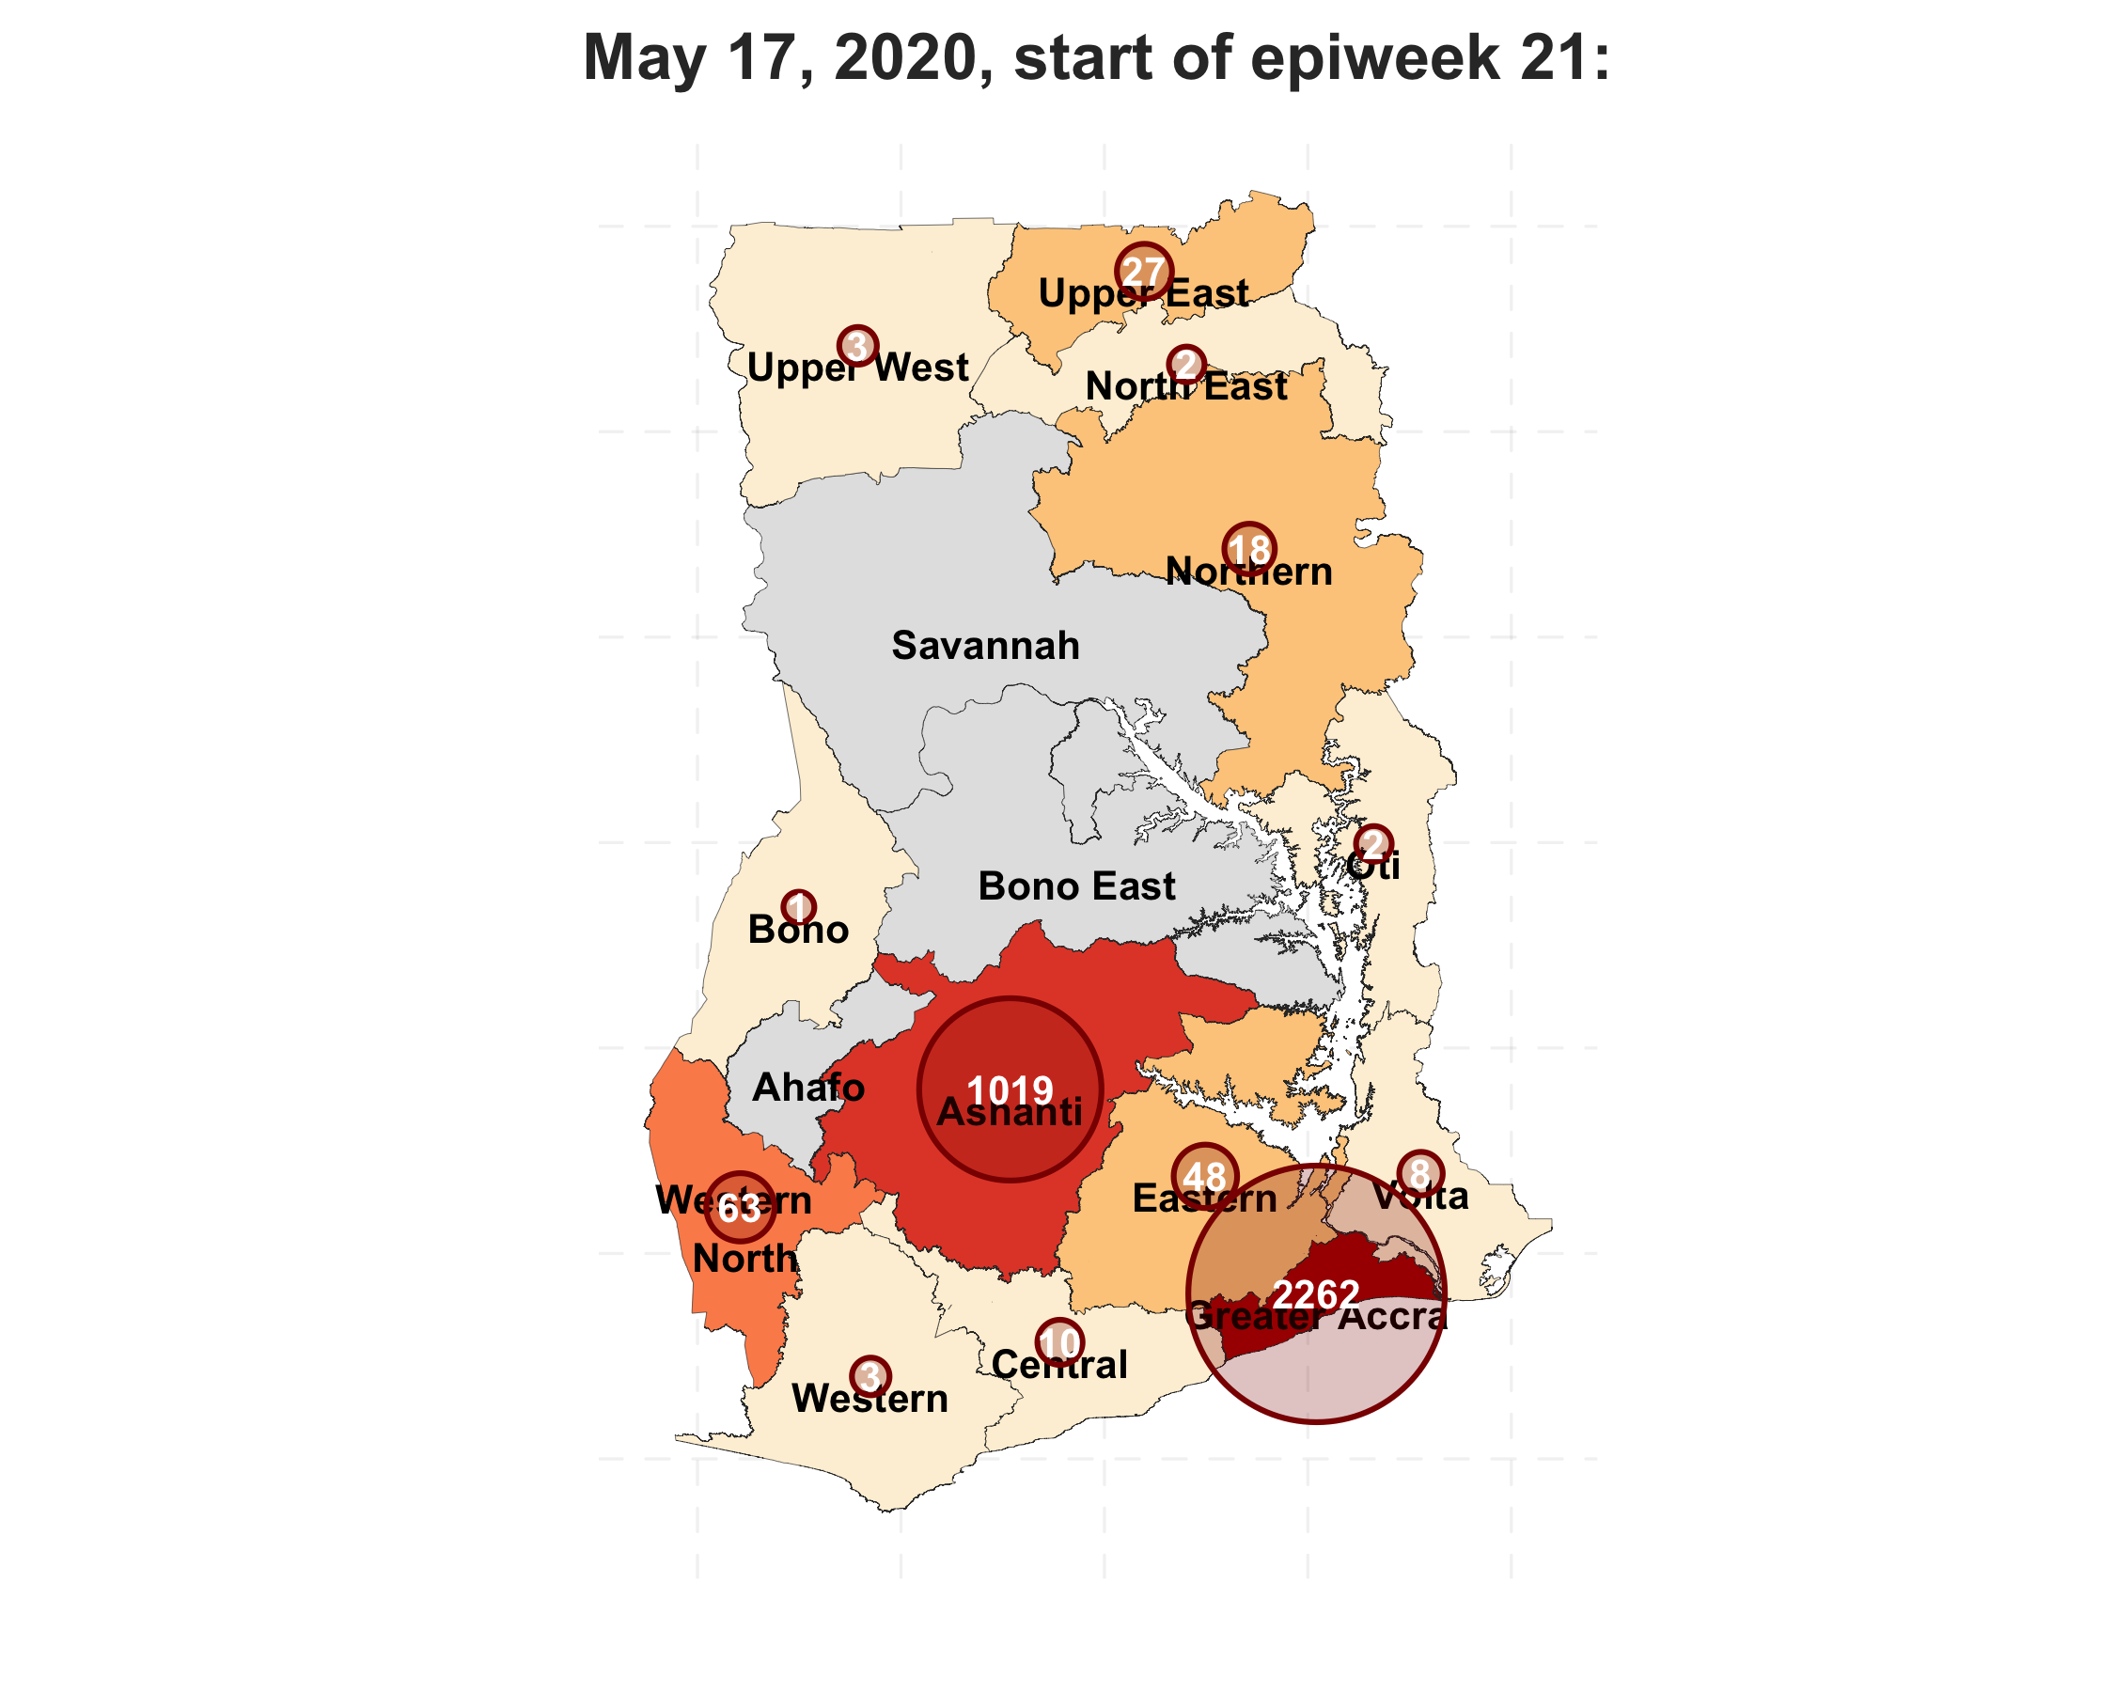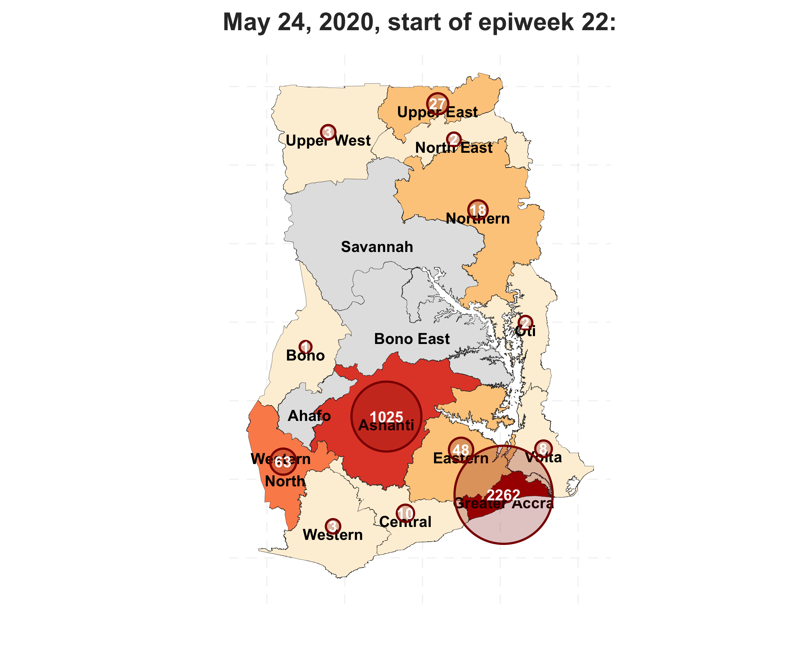

The two most affected areas in Ghana are Great Accra and Ashanti with smaller clusters of cases in other regions. This distribution was explained by the first cases coming through the Kotoka International Airport (in Greater Accra) and later through national roads that connect Greater Accra with other regions and neighbours countries ([Trans–West African Coastal Highway](https://en.wikipedia.org/wiki/Trans%E2%80%93West_African_Coastal_Highway)).